1)Tasks To Be Performed:
1. Pull Ubuntu container
2. Run this container and map port 80 on the local
3. Install Apache2 on this container
4. Check if you are able to access the Apache page on your browser

launch ubuntu ec2 instance:

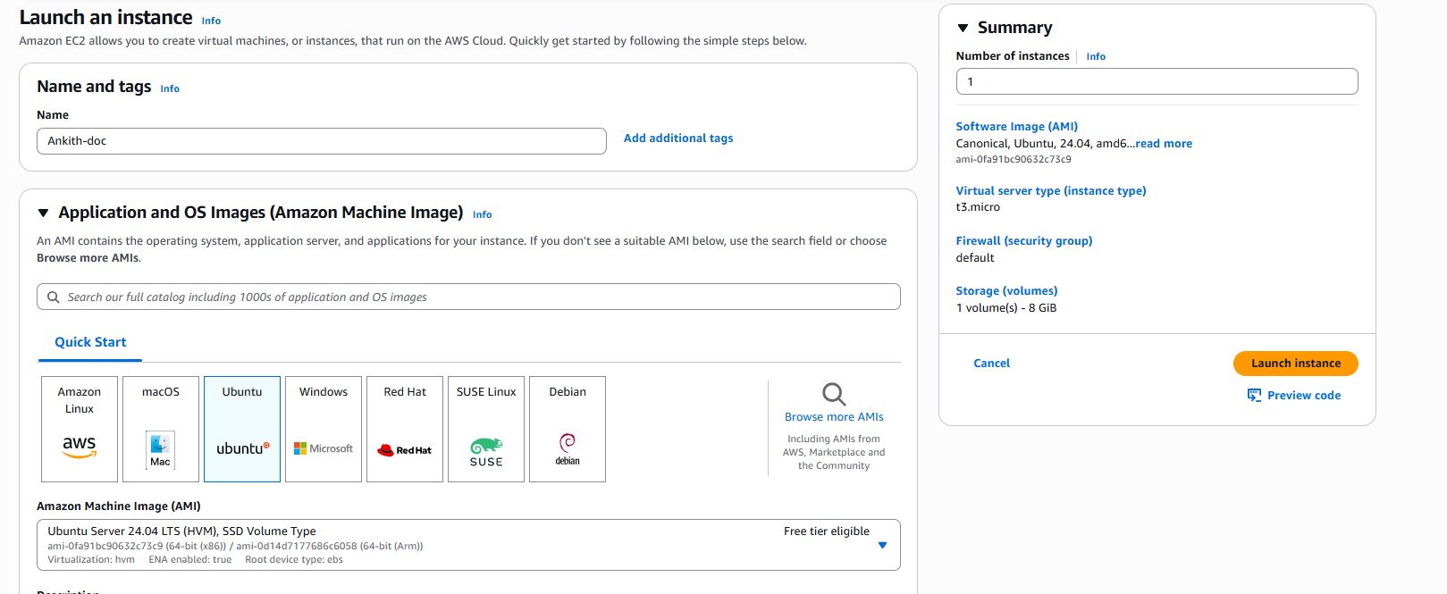
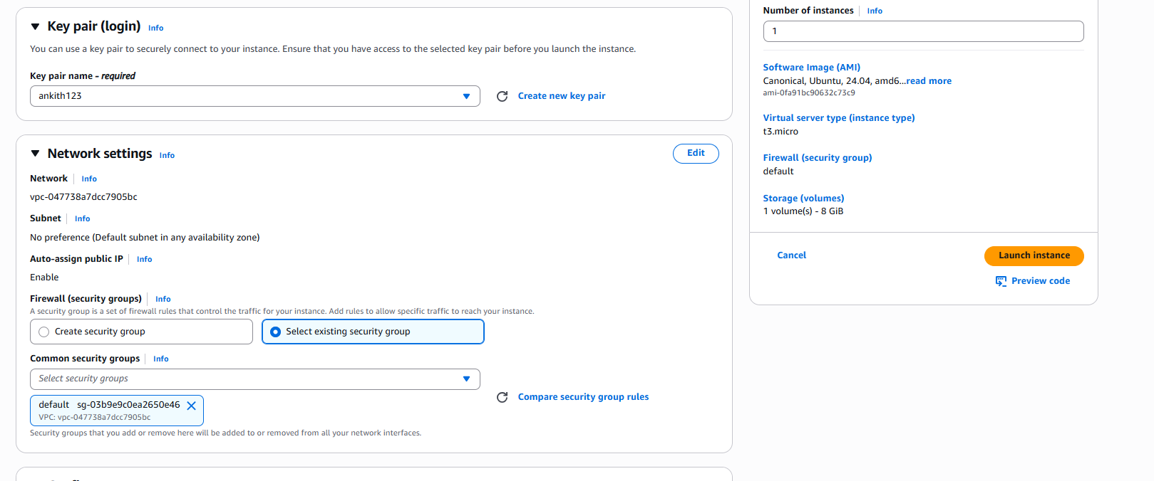
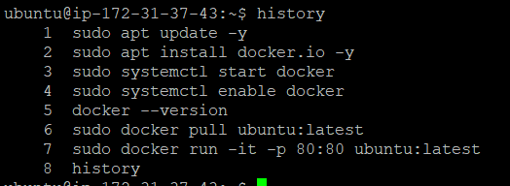
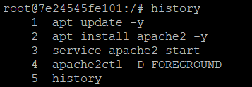

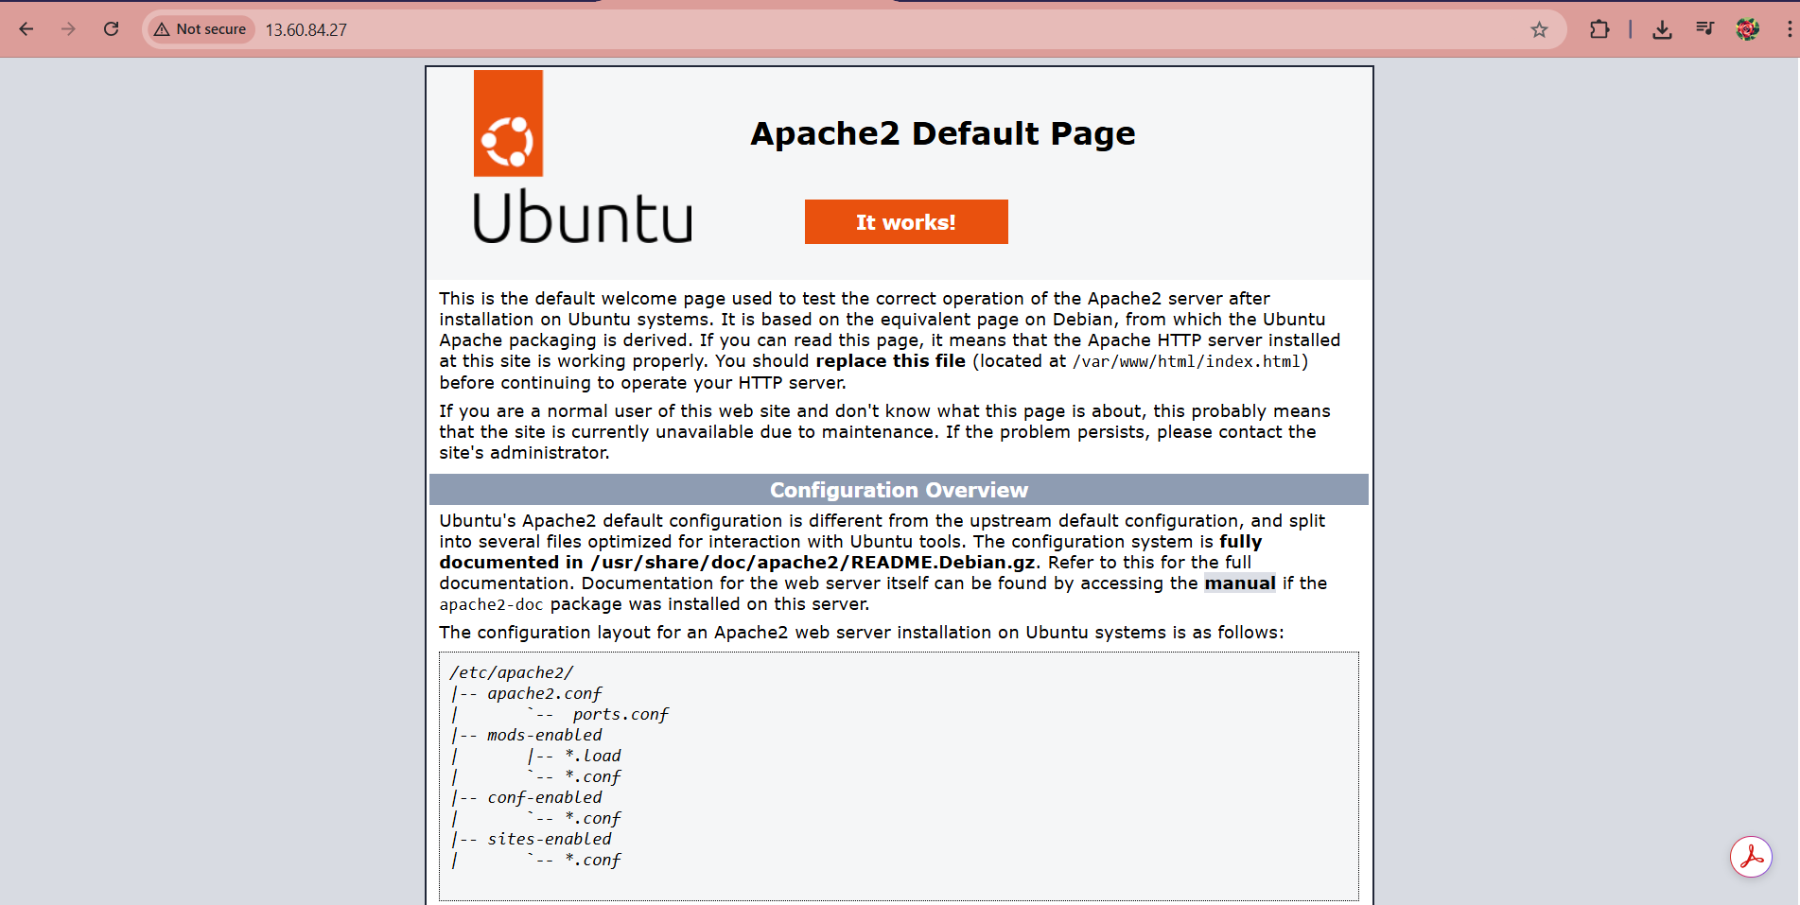

2)Tasks To Be Performed:
1. Save the image created in assignment 1 as a Docker image
2. Launch container from this new image and map the port to 81
3. Go inside the container and start the Apache2 service
4. Check if you are able to access it on the browser
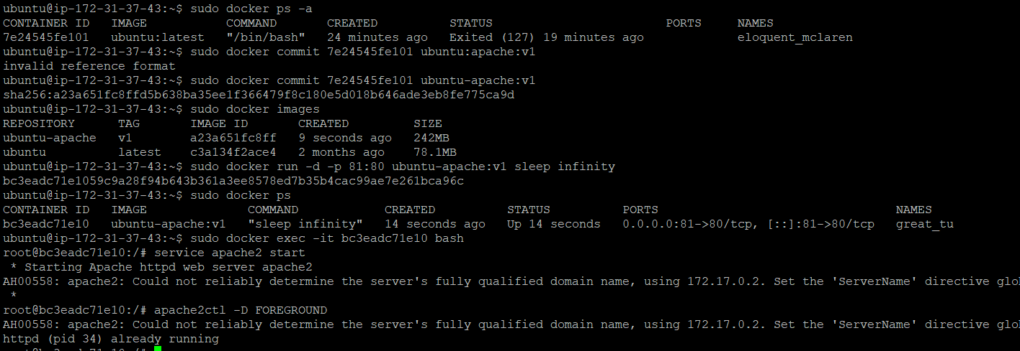

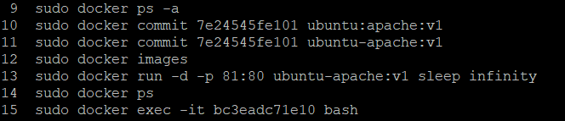
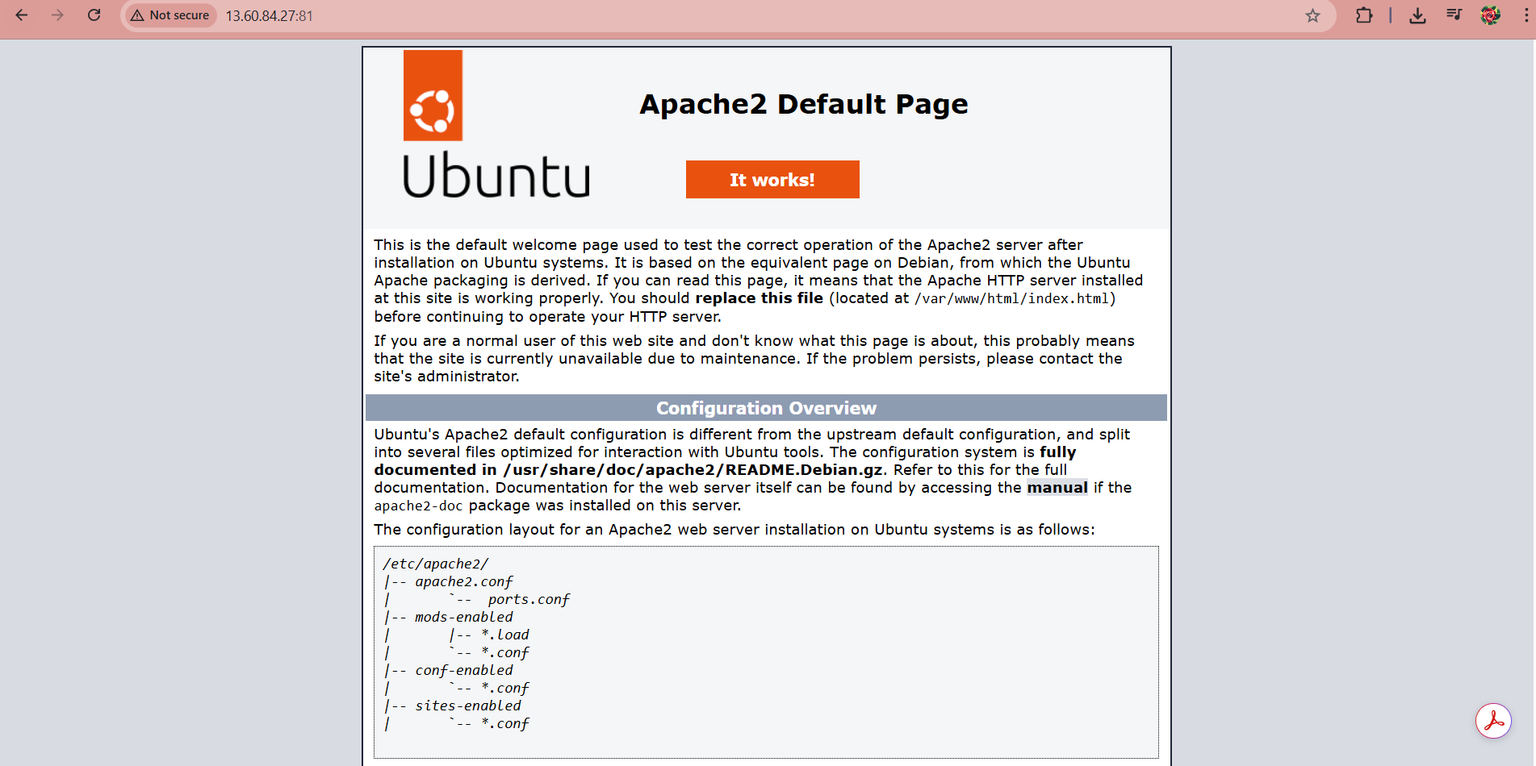

3)Tasks To Be Performed:
1. Use the saved image in the previous assignment
2. Upload this image on Docker Hub
3. On a separate machine pull this Docker Hub image and launch it on port
80
4. Start the Apache2 service
5. Verify if you are able to see the Apache2 service
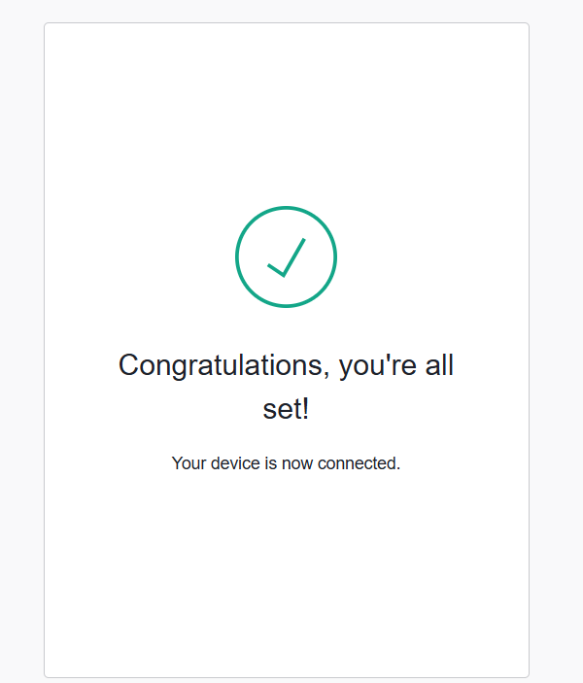

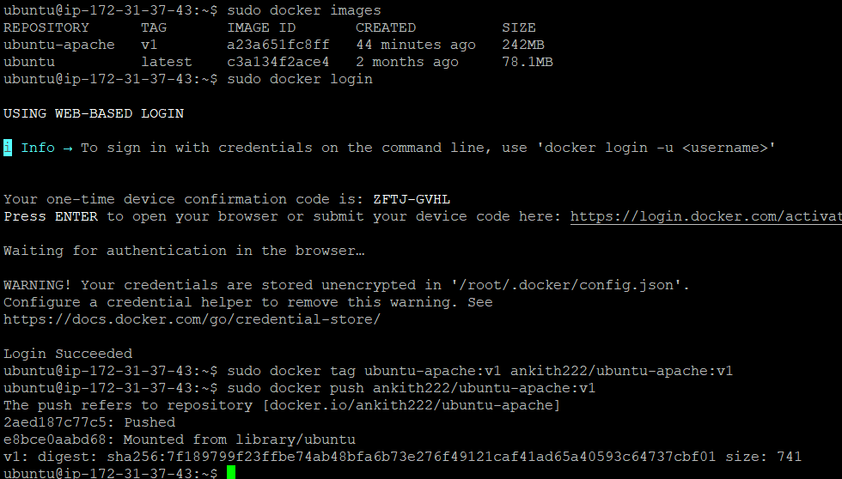

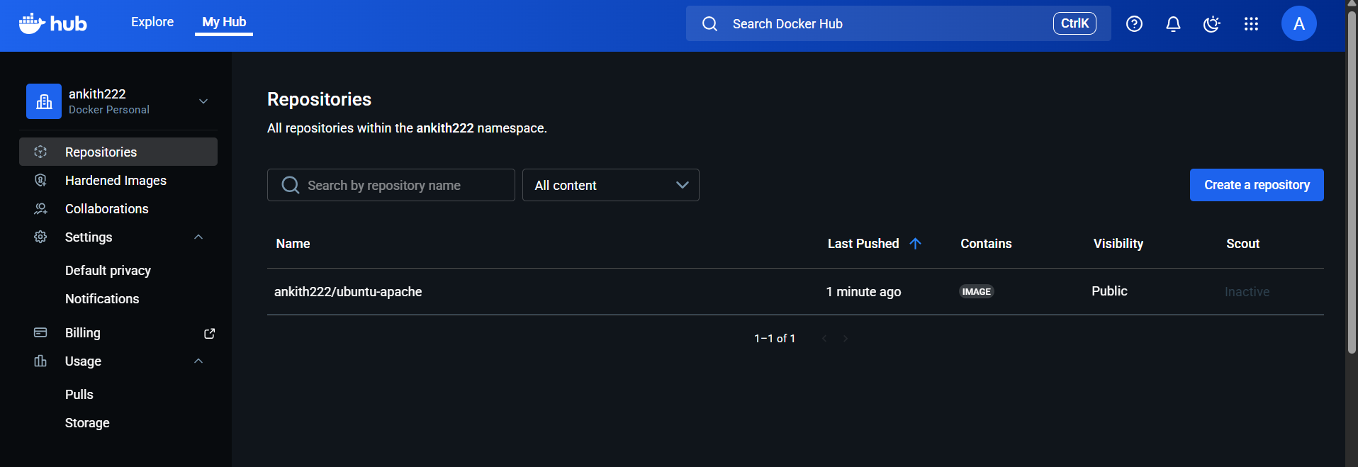
launching new instance and pulling image

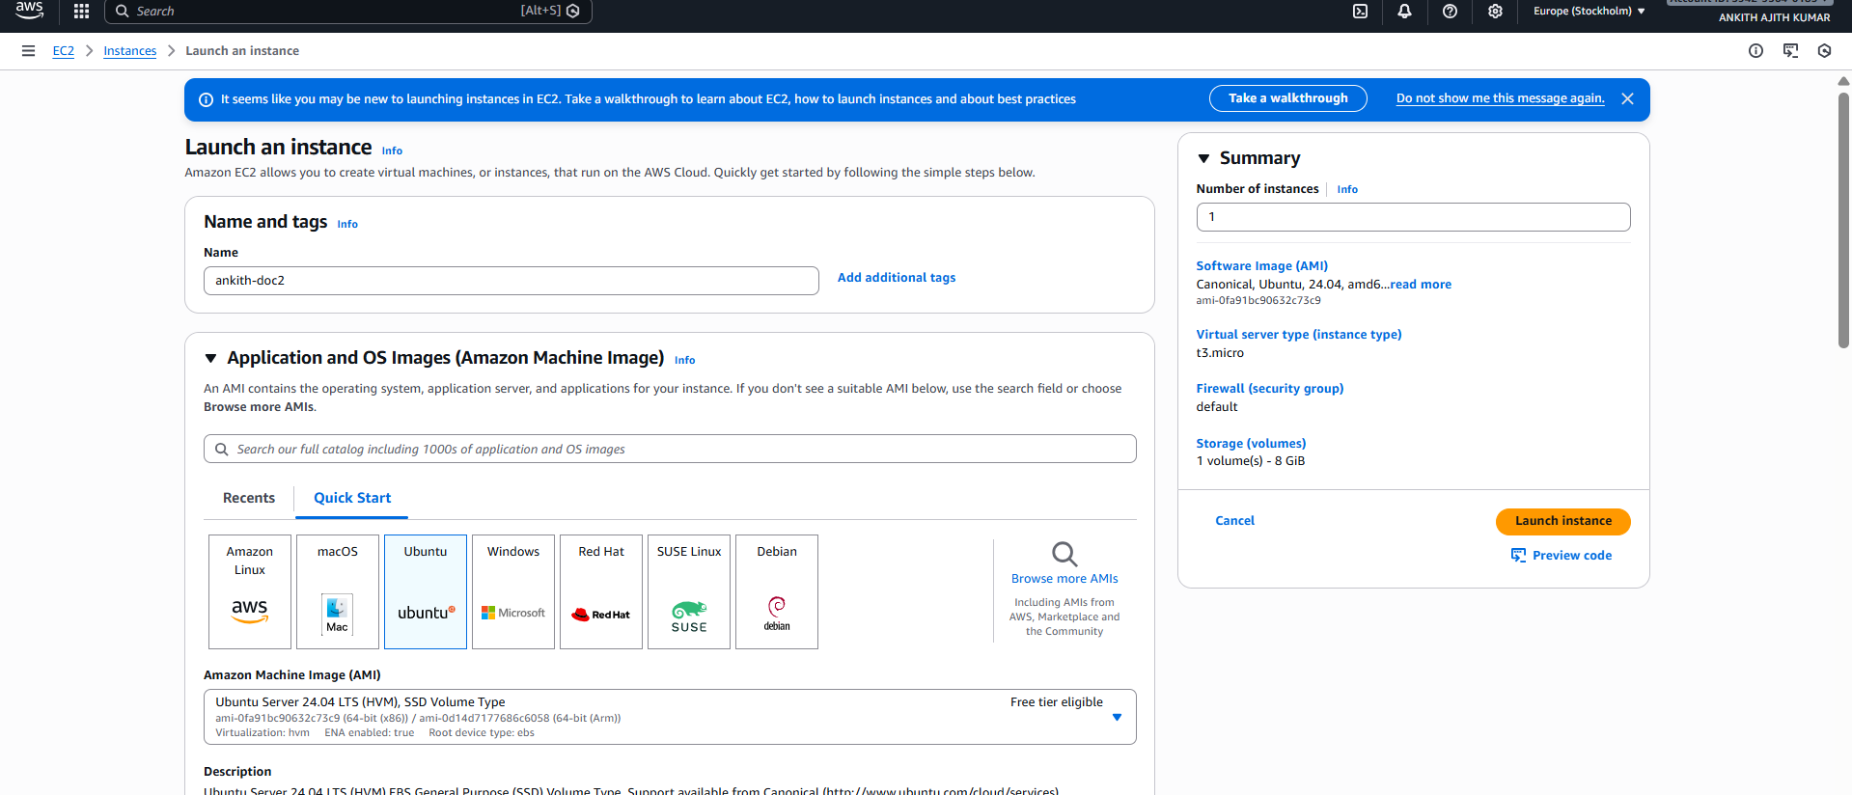
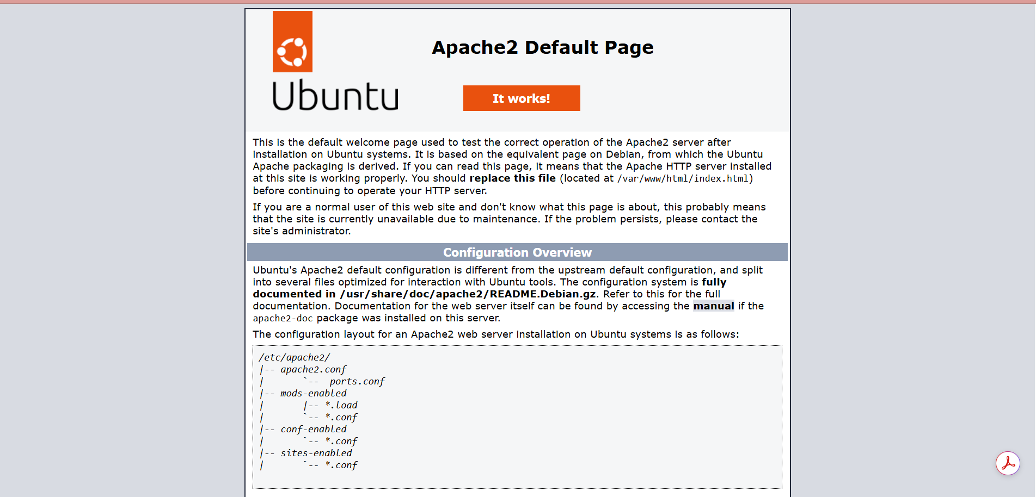

4)Tasks To Be Performed:
1. Create a Dockerfile with the following specs:
● Ubuntu container
● Apache2 installed
● Apache2 should automatically run once the container starts
2. Submit the Dockerfile for assignment completion

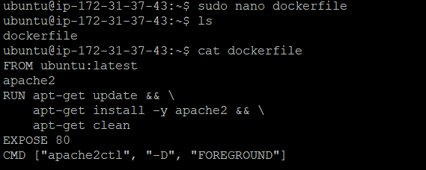
5)Tasks To Be Performed:
1. Create a sample HTML file
2. Use the Dockerfile from the previous task
3. Replace this sample HTML file inside the Docker container with the default
page

